Order Of Service

Singing: Psalm 92—CW page 101

Reading: Psalm 142

Opening Hymn: TLH 55

Reading: I Peter 2:1-10

Request Hymn: CW Supplement 769

Reading: Luke 21:5-24

Sermon Hymn: TLH 521

Sermon Text: Song Of Solomon 2:7

Till He Please

Prayer

The Apostles’ Creed, TLH page 12

Holy Communion

The Lord's Prayer

The Blessing

Closing Hymn: TLH 68

* * * * * * * * * * *

Bible Study: Lambs: Exodus 20:3; Love God First
Sheep: Proverbs 6:26-35; Your Choice
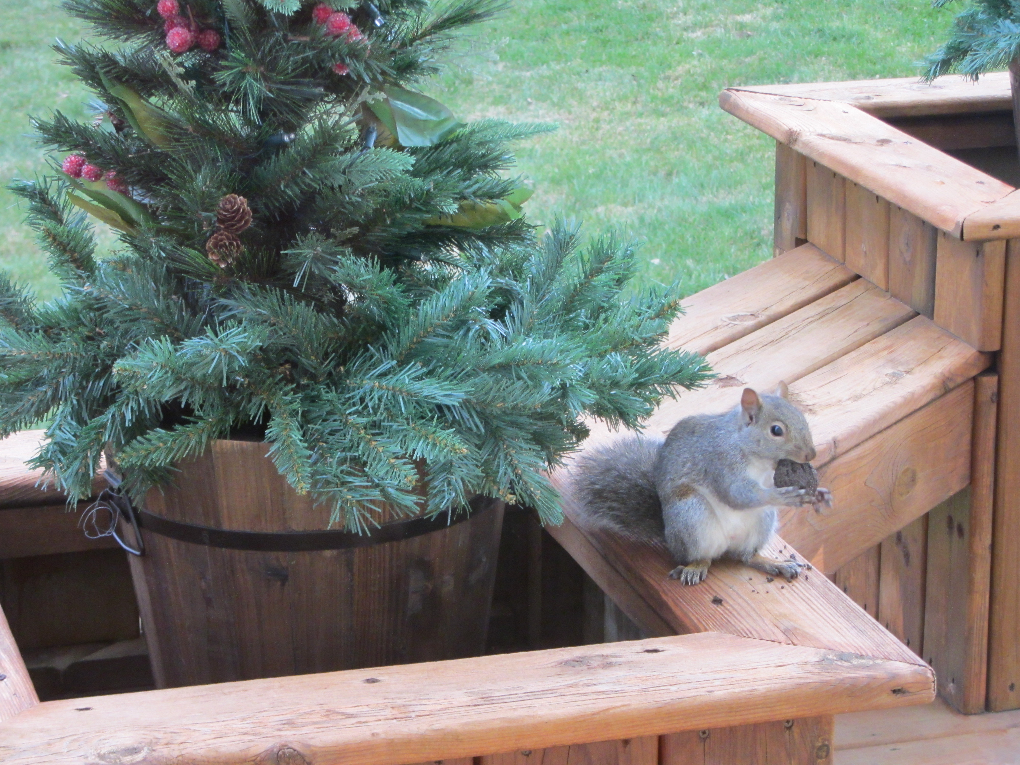

Bulking Up for Winter

Water
Of
Life
13 December 2015

W A T E R O F L I F E

Independent Christian Church—Conservative Lutheran Doctrine

Worship Service: 9:30 a.m. Bible Study: 10:45 a.m.

Larry Cooper, Pastor E-Mail address:
111 N. Ridge Road lcooper@wateroflife.cc
Coon Valley, WI 54623 Web Site:
Phone: (608) 452-2105 www.wateroflife.cc

* * * * * * * * * * * * * * * * * * * * * * * * * * *

Sermon Text: Song Of Solomon 2:7

Till He Please

* * * * * * * * * * * * * * * * * * * * * * * * * * *

Song of Solomon 2:7 I charge you, O ye daughters of Jerusalem, by the roes, and by the hinds of the field, that ye stir not up, nor awake my love, till he please.

Daughters of Jerusalem

This is not the first time we have heard of the daughters of Jerusalem here in the book of Song Of Solomon. Nor will it be the last time. Because of the importance of this mysterious group of people, let us see what the Holy Spirit tells us of them.
Facts concerning the daughters of Jerusalem:

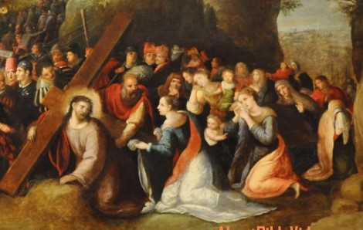

The phrase daughters of Jerusalem occurs eight times in the KJV of the Bible. Seven of these times it occurs in the Old Testament. And all seven of the occurrences are in Song Of Solomon. One time the phrase occurs in the New Testament.

The eight occurrences of “daughters of Jerusalem”:

Song of Solomon:
1:5
2:7
3:5
3:10
5:8
5:16
8:4

Gospel of Luke: 23:28

Four times in Song Of Solomon the Bride charges (commands) the daughters of Jerusalem. (2:7, 3:5, 5:8, 8:4.) One time the daughters of Jerusalem repeat the word “charge” in question form. (5:9). Five is the number of grace in Scripture.

